STAR WARS SPRING 2018 PRODUCT DESCRIPTIONS

Recreate classic moments from the STAR WARS saga and get ready for all new adventures as SOLO: A STAR WARS STORY races into theaters in May 2018! Fans will be able to imagine their own stories with HASBRO’s new line of action figures and vehicles featuring beloved characters such as HAN SOLO, CHEWBACCA, and LANDO CALRISSIAN.

Items from the Spring 2018 STAR WARS product line include:

FORCE LINK ACTION FIGURES

STAR WARS FORCE LINK 2.0 STARTER SET
(Ages 4 years & up/Approx. Retail Price: $29.99/Available: Spring 2018)
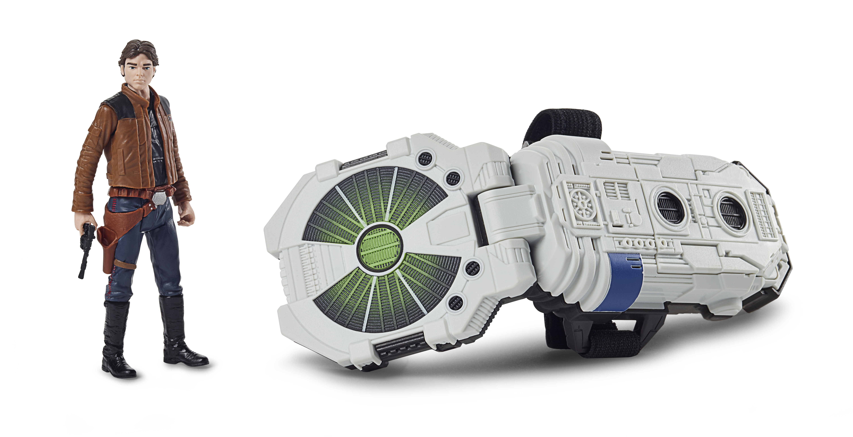Bring STAR WARS adventures to life with the newly designed FORCE LINK 2.0 STARTER SET including FORCE LINK wearable technology, which allows fans to activate movie sound effects and phrases in more than 30 compatible STAR WARS toys! Use the Force with an exclusive 3.75-inch HAN SOLO figure only available in the FORCE LINK 2.0 STARTER SET, featuring unique sounds and expressions from SOLO: A STAR WARS STORY. FORCE LINK technology unlocks an extensive collection of sounds and phrases with compatible figures, accessories, vehicles, and playsets. Includes FORCE LINK wearable technology and exclusive 3.75-inch figure. Compatible with all products in the FORCE LINK line, each sold separately. Requires 3 AAA batteries, not included. Available at most major retailers.
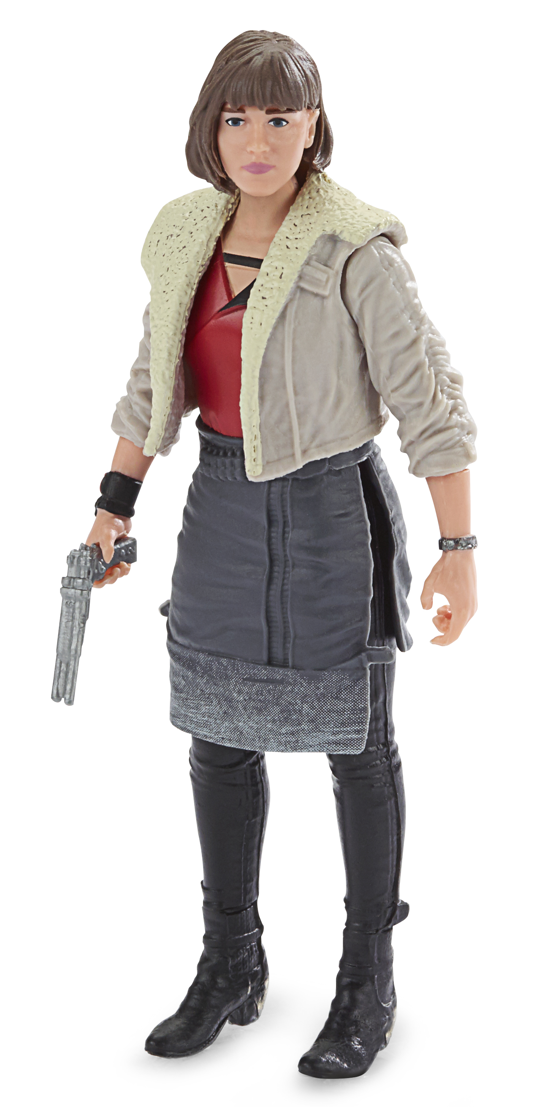
STAR WARS 3.75-INCH FIGURE Assortment
(Ages 4 years & up/Approx. Retail Price: $7.99/Available: Spring 2018)
Enter the world of STAR WARS and launch into action and adventure! Each 3.75-inch figure features five points of articulation and comes with unique battle accessories. Characters include classic heroes and villains, as well as favorite characters from SOLO: A STAR WARS STORY, STAR WARS: THE LAST JEDI, and ROGUE ONE: A STAR WARS STORY such as CHEWBACCA, LUKE SKYWALKER, QI’RA, K-2SO, MAZ KANATA, and more. Activate an array of sounds and phrases specific to each character with FORCE LINK 2.0 wearable technology. FORCE LINK wearable technology is compatible with all products in the FORCE LINK line, each sold separately. Available at most major retailers.

FORCE LINK VEHICLES

SOLO: A STAR WARS STORY 3.75-INCH KESSEL RUN MILLENNIUM FALCON VEHICLE
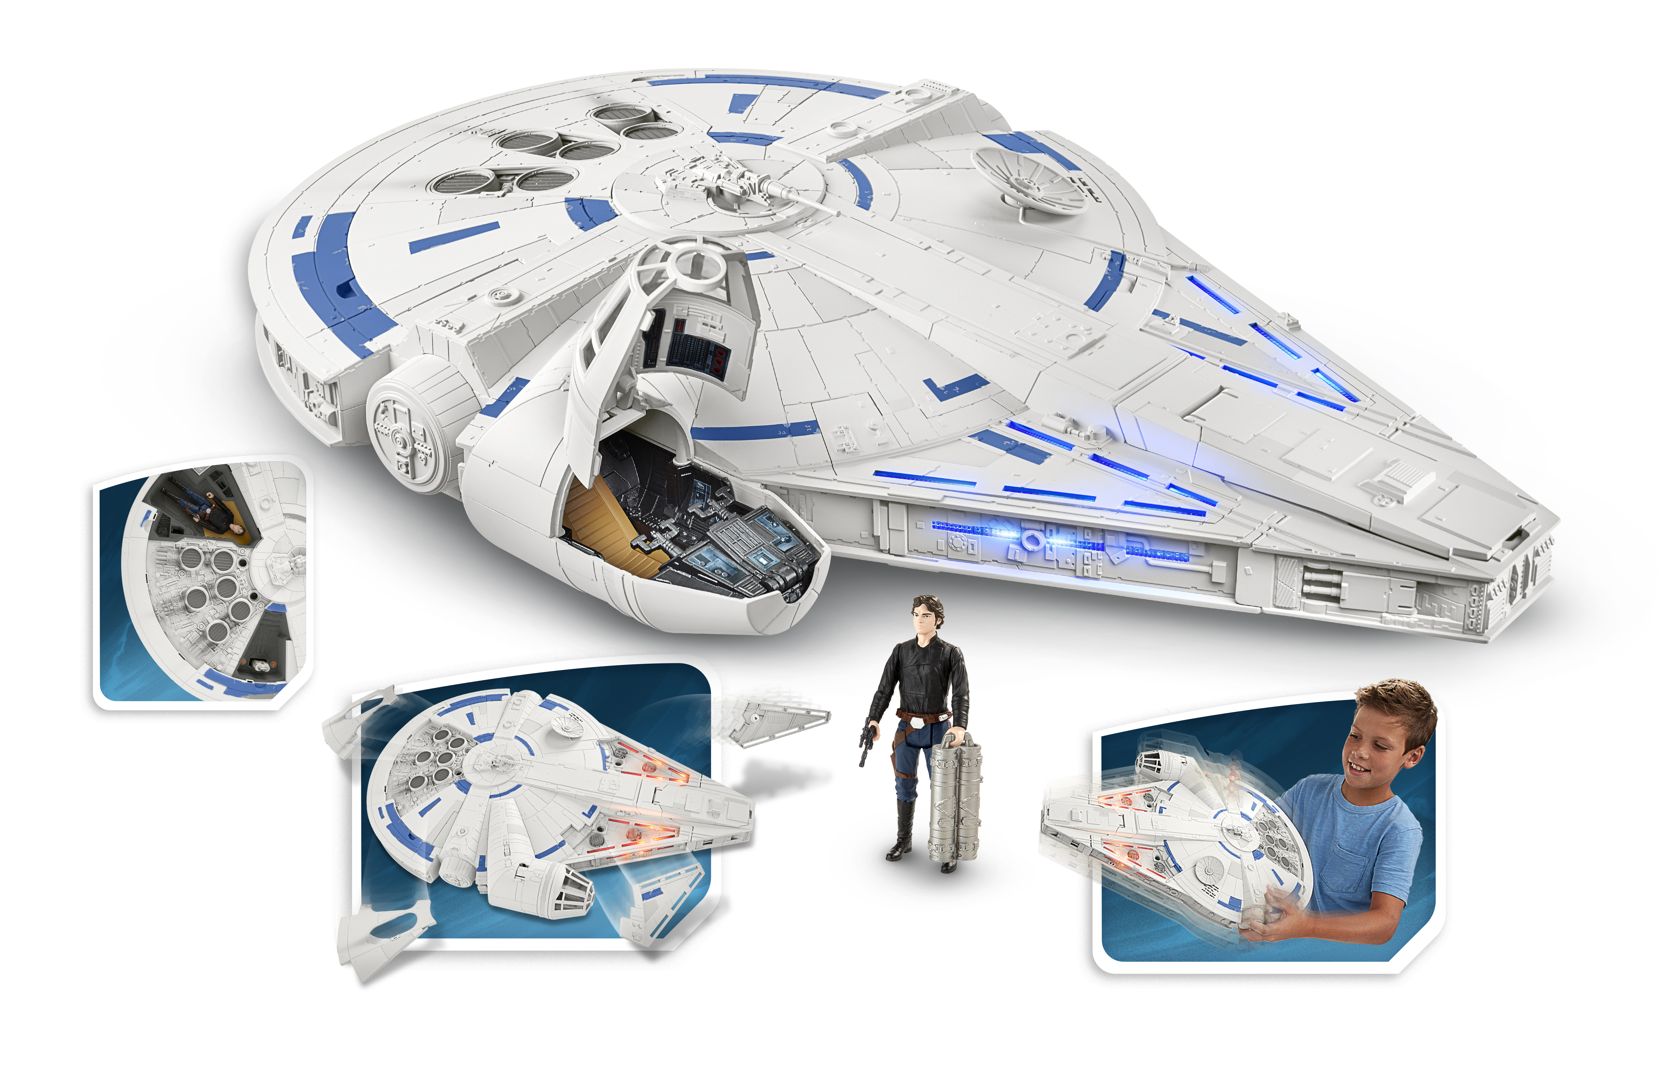 (Ages 4 years & up/Approx. Retail Price: $99.99/Available: Spring 2018)
Make the KESSEL RUN in less than 12 parsecs with the MILLENNIUM FALCON! Relive the adventure and imagine flying through every obstacle like ace pilot HAN SOLO with speed and action. Fans will experience flashing lights and sounds as they pretend to race along KESSEL RUN. Press the button to pretend that the iconic starship kicks in to hyperdrive with lights and sounds. Press the button a second time for accelerated lights and sounds as well as activate the rumble pack vibrations! Push the button a third time to pretend that your ship picks up even more speed and watch the panels pop off before rumbling to the finish line! Comes with an exclusive 3.75-inch scale HAN SOLO figure and removable mini ship. Both the figure and mini ship are FORCE LINK 2.0 enabled, with phrases and sounds activated by the wearable technology, sold separately. Includes 1 vehicle (with removable mini ship) and 1 figure. Requires 3 AA batteries, included. Available at most major retailers.

STAR WARS: THE BLACK SERIES Action Figures
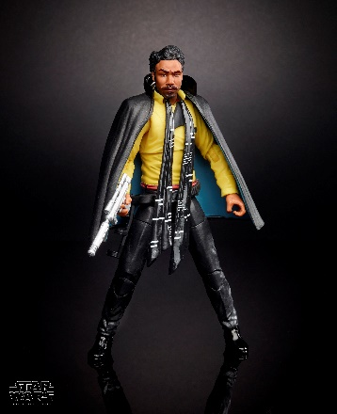
STAR WARS: THE BLACK SERIES 6-INCH Figure Assortment
(Ages 4 years & up/Approx. Retail Price: $19.99/Available: Spring 2018)
Take your STAR WARS collection to the next level with these incredibly detailed figures. These premium 6-inch scale figures are designed with extensive detail and articulation for the ultimate collector. Characters include HAN SOLO, LANDO CALRISSIAN, and more. Each figure sold separately. Available at most major retailers and on HasbroToyShop.com.

# # #

